USE CASES

**BBQReserver**

Developer: Team 4

Vladimir Solovev  
Vladimir Semenov  
Marvin Lopez  
Valeriia IUrinskaia

Received Requirements

* System must be built on Telegram bot technologies.
* User should be able to add, delete, modify the reservation.
* User should be able to see the list of all his reservations.
* User should be able to make multiple reservations.
* User should be able to see the reservations schedule (for day, week, month).
* User should be able to report to concierge service about troubles in the BBQ zone.
* Bot should recommend a different hour if the requested time is already booked.

Features Requirements

* User must interact with the system mostly with buttons and input some non-discrete data as a text
* User must enter his/her phone number in every reservation
* User should be able to add comments to the reservation.
* User should be able to add only one reservation per 12 hours.
* Limit should be 1 month for reservation period.

Use Case diagram

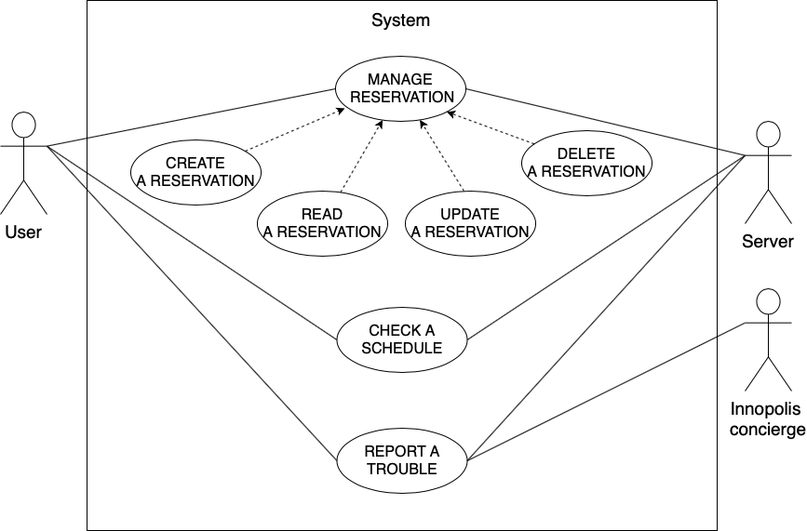

Use case scenarios

|  |  |
| --- | --- |
| **Use Case Code US001** | Update reservation record |
| **Actors** | User, Server |
| **Pre-conditions** | User has a reservation record and request update |
| **Assumptions** | User wants to update something in his record |
| **Flow of events** | 1. User request update for his record 2. User choose data to modify 3. System validates the data   3.1 If new data is valid - modify record  3.2 If something went wrong - return error   1. User receive confirmation message |
| **Post-conditions** | Server informs the user is update successful or not |
| **Alternate flow** | There could be some system or network error, send user notification to try again |

|  |  |
| --- | --- |
| **Use Case Code US002** | Create a new reservation |
| **Actors** | User, Server |
| **Pre-conditions** | The user wants to reserve the time at the BBQ place |
| **Flow of events** | 1. User clicks “Create new reservation” button 2. User enters a time interval 3. System checks if the time interval is available 4. Server approves the time interval 5. User enters a comment (optional) 6. User approves his reservation request 7. Server saves reservation to the schedule |
| **Post-conditions** | The schedule is updated by adding a new entry. |
| **Alternate flows and exceptions** | The inputted time interval is not available |
| **Issues** | Duplicates the existing Concierge service feature |

|  |  |
| --- | --- |
| **Alternative Name** | The inputted time interval is not available |
| **Actors** | User, Server |
| **Insertion point** | Server checks if the time interval is unavailable |
| **Pre-conditions** | The inputted time interval is not available |
| **Flow of events** | 1. Server proposes a time that is close to inputted one 2. User selects one of the proposed time intervals 3. Server approves the time interval |
| **Post-conditions** | Server has approved time interval for reservation |

|  |  |
| --- | --- |
| **Use Case Code US003** | Delete a booking record |
| **Actors** | User, Server |
| **Pre-conditions** | User has a booking record |
| **Assumptions** | - |
| **Flow of events** | 1. User press modify button 2. User press delete button 3. System asks for confirmation 4. System delete the record 5. User receives confirmation message |
| **Post-conditions** | The reservation is deleted. |
| **Alternate flow** | 1. User cancels the operation 2. System return to the Modify screen |

|  |  |
| --- | --- |
| **Use Case Code US004** | Read reservation record |
| **Actors** | User, Server |
| **Pre-conditions** | Reservation exists |
| **Assumptions** | The user want to check his reservation |
| **Flow of events** | User enters the system and click it reservation  User see his reservation data and can edit it or read |
| **Post-conditions** | none |
| **Alternate flow** | Network error, system suggest user to try again |

|  |  |
| --- | --- |
| **Use Case Code US005** | Checking a schedule |
| **Actors** | User, Server |
| **Pre-conditions** | The user's location is in the system, the system shows to the user main menu |
| **Assumption** | The user wants to view the schedule for some time period (day, week, month) |
| **Flow of events** | 1. The user selects a schedule check in the menu 2. The system shows all reservations at once |
| **Post-conditions** | The system shows the user all reservations |
| **Alternative flows** | None |

|  |  |
| --- | --- |
| **Use Case Code US006** | Report a Trouble |
| **Actors** | User, Server, Innopolis concierge |
| **Pre-conditions** | - |
| **Assumptions** | The user has an internet connection |
| **Flow of events** | 1. User press “Report” button 2. User fill the form for “Report a Trouble” 3. User Attach a photo 4. User Submit the report 5. System register the report 6. System forward information to Innopolis concierge |
| **Post-conditions** | Innopolis concierge receive the report |
| **Alternate flow** | 1. User cancels the operation 2. System return to Home Page 3. User insert non-supported image format 4. System display error message 5. System return to Home Page |
| **Issues** | Removed as the user case is duplicating the existing Concierge service feature [2] |

|  |  |
| --- | --- |
| **Use Case Code US002.1** | Create a new reservation |
| **Actors** | User, Server |
| **Pre-conditions** | The user wants to reserve the time at the BBQ place |
| **Flow of events** | 1. User clicks “Create new reservation” button 2. System shows only the available time periods 3. User selects the time interval 4. Server approves the time interval 5. User approves his reservation request 6. Server saves reservation to the schedule |
| **Post-conditions** | The schedule is updated by adding a new entry. |
| **Alternate flows and exceptions** | None |

Glossary of relevant domain terminology

User Anyone using the system

Server The application backend

System Barbecue reservation system including all its features

Innopolis concierge Innopolis city assistance

Booking record A new system approved reservation record

Schedule

Daily schedule - day intervals for booking

Weekly schedule - weekly time data

Monthly Schedule - monthly time data

Selecting of time period Select start and end time for booking

Home Page telegram bot starting interface

Appendix

“Create reservation” use case

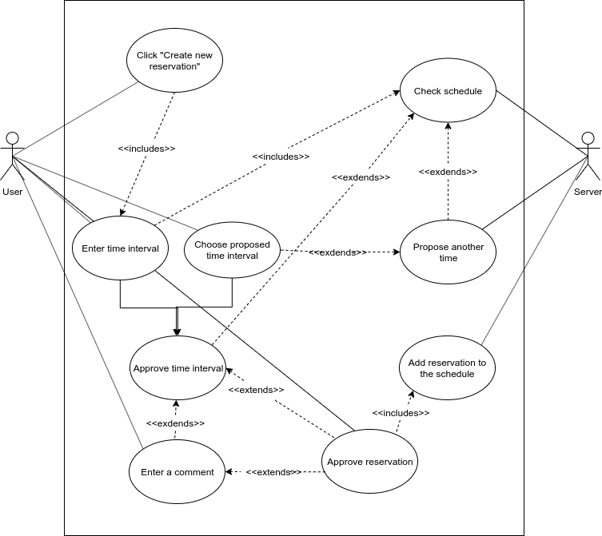

“Check the schedule” use case

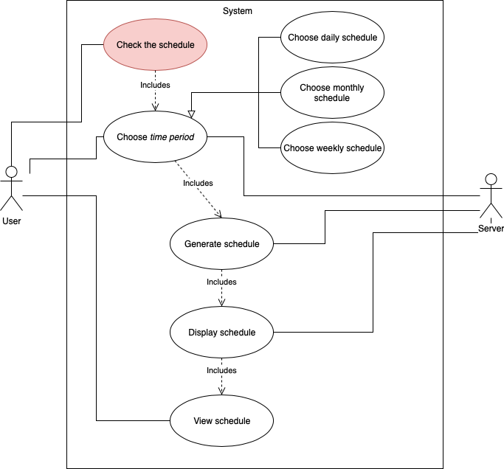

Sources:

1. Initial interview
2. Interview